***Official Premium List***

# wcobc logo

**WHIPPET CLUB OF BRITISH COLUMBIA**

Announces

**TWO CKC LURE FIELD TRIALS** September 24 & September 25, 2016

These Events Held Under the Rules of the Canadian Kennel Club

**To Be Held At:**

The Icelandic Horse Farm field on Langford Road, Lavington, BC

**Certification Runs** – Friday September 23, 2016 – **MUST** be reserved with

Field Trial Secretary by September 16, 2016

Mail **ALL** Entries To:

Marion Bomford

Field Trial Secretary

504-1915 Pacific Court

Kelowna, BC V1Y 8B3

E-mail: bomford@shaw.ca

(250) 762-6778

Limit of 50 Hounds Per Day

**Field Trial** **Pre-Entry** **Closes**  **September 17, 2016**

**Field Trial Post Entry** **Closes**: Saturday – **8:30** a.m Coursing Official Classes & Singles

Saturday - **1:00** p.mPuppies & Fun Run Participants

Sunday - **8:30** a.m. Coursing Official Classes & Singles

**Roll Call:** Saturday **– 9:00** a.m Coursing Official Classes, Singles

Saturday - **1:30** p.mPuppies & Fun Run Participants

Sunday - **9:00** a.m Coursing Official Classes & Singles

Rolling Inspection from arrival to Roll Call

**ENTRY FEES:**

**LURE FIELD TRIAL**

**Pre-entry, first hound** (closes September 17, 2016) $22.00

**Pre-entry, each additional hound same owner $**20.00

**Post entry** (after September 17, 2016) $30.00

**Listing Fee for each entry without a CKC Number PER EVENT**  $ 9.32

**Note: each entry includes $4.94 CKC fee per event**

**SINGLE**  $15.00

**LURE COURSE STAKES OFFERED**

* **Open Stake** - for all dogs, including Field Champions
* **Mixed Stake** – for multiple breeds with entries of three or less, upon agreement of all owners
* **Single runs** – hounds run alone. No points awarded to winners.

**PUPPY, FUN RUN (Saturday, September 24, 2016 only)** $ 5.00

Contact Verena Von Eichborn at 250-260-3109 or email to [eichbornshuse@telus.net](mailto:eichbornshuse@telus.net)

Limit 10 dogs

***Versatility whippet of the Year***

This Lure field trial show, a qualifying events for whippets gathering credits toward the Whippet Club of BC Versatility award of 2017.

*Whippets winning this award receive a certificate providing free entry to all WCOBC events for one year.*

***For more details on this award contact*** [***wcobc@shaw.ca***](mailto:wcobc@shaw.ca)

***Back by popular demand is the Berlin Friend and Family Jam and Jelly sale!***

|  |  |
| --- | --- |
| *The funds raised from the sale of these tasty products go towards paying our many expenses incurred in hosting whippet and sighthound events.*  *Return of empty jars is much appreciated.* | *MC900001752[1]* |

**COURSING JUDGES:**

|  |
| --- |
| **Pat Ingram** (PI)  PO Box 20, Site 27, RR7, Calgary, AB, T2P 2G7  **Linda Smith** (LS)  11228 100 Ave NW, Edmonton, AB T5K 0H9  **Debra Verzyl** (DV)  11081 North Watts Road, Ladysmith, BC V9G 1Y6  **Barbara (Bobbi) Westman** (BW) *\* Provisional for Pharoah Hounds, Deer Hounds and Wolf Hounds*  10818 79Ave, Edmonton, AB, T6E 1S5 |

**COURSING JUDGING ASSIGNMENTS:**

|  |  |  |
| --- | --- | --- |
|  | **Sat September 24** | **Sun September 25** |
| **Afghan** | **LS PI** | **BW DV** |
| **Basenji** | **BW PI** | **LS PI** |
| **Borzoi** | **LS PI** | **BW DV** |
| **Deerhound** | **LS BW\*** | **BW* PI** |
| **Greyhound** | **LS PI** | **LS DV** |
| **Ibizan** | **BW DV** | **BW DV** |
| **Irish Wolfhound** | **BW* DV** | **BW* PI** |
| **Italian Greyhound** | **LS DV** | **LS PI** |
| **Pharaoh Hound** | **BW* DV** | **BW* LS** |
| **Saluki** | **LS DV** | **DV PI** |
| **Whippet** | **BW PI** | **DV PI** |
| **Mixed Stakes** | **TBA** | **TBA** |
| **Singles** | **TBA** | **TBA** |

**RUNNING ORDER BOTH DAYS: TO BE ANNOUNCED AT ROLL CALL**

|  |  |  |
| --- | --- | --- |
| **COURSE PLANS:**  **Saturday 850 yds** | **Sunday 710 yds** |  |
|  |  |  |

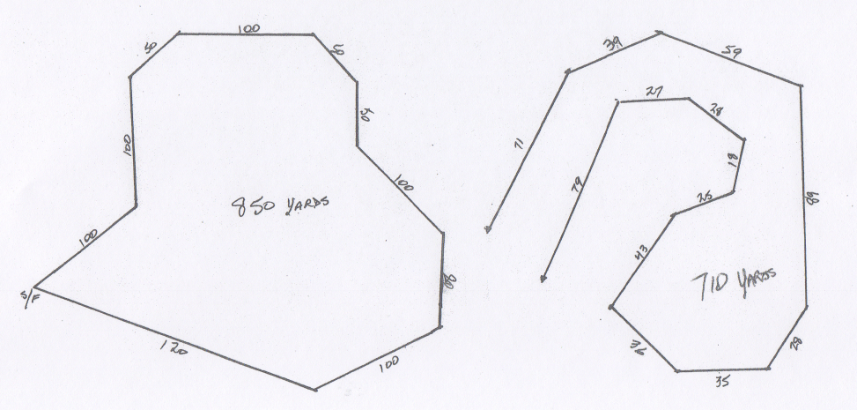

### EQUIPMENT & FIELD CONDITIONS

Course plans not to scale & may be altered to suit weather conditions.

Battery powered drag line with white plastic streamers.

The field is gently rolling pasture

**NOTES AND INFORMATION**

1. All handlers must use a slip lead when releasing their hounds;
2. Hounds may wear muzzles and/or catch collars at the owner/agent's discretion. Leg wraps must be in neutral colours;
3. Bitches in season and lame hounds will be excused and will have their entry fee returned if notice is given to the secretary **prior** to roll call. A Veterinarian certificate may be required;
4. The Chairman may excuse any hound from competition for any reason deemed justifiable;
5. A $10.00 fine, payable to WCOBC, will be levied for any hound loose on the field at any time between Roll Call and the completion of Regular classes;
6. A $10.00 fine, payable to WCOBC, will be levied for any exhibitor not cleaning up after their dog;
7. There is limited shade and no water available, so please come PREPARED;
8. There will be limited overnight camping. Please contact Fiona at wcobc@shaw.ca
9. Please be prepared with your bag lunch as there are no restaurants close by, however there is a gas station and some eats at the corner of Hwy 6 and School Road about 10 minutes away;
10. It shall be the duty and obligation of the trial-giving club to see that a judge, club official,

Volunteer, or any participant at an event held under these rules is not subject to indignities of any kind. The Field Trial Committee Chair shall promptly report to the CKC any infringement of this regulation and the Discipline Committee shall have the authority to take such action as it deems fit on receipt of a report indicating that this has occurred.

**PRIZES AND AWARDS**

**Field Trial**

* Rosettes & a prize will be awarded to **Best of Breed** & **1st in Mixed Stake**
* Rosettes will be awarded **2nd** to **NBQ**
* Prize awarded for top scoring **Single** each day
* Turtle prize will be awarded to hound with the **lowest** qualifying score each day

**Boosters for top hounds on Saturday:**

* **Field Champion**
* **Field Champion Excellent**
* **Veteran**
* **First time entered**

**High Point Aggregate for Spring Trial:** awarded Sunday, scores from both days to determine. In the event of a tie, awarded to hound present at ‘Sunday ribbon ceremony’, followed by ‘pulling of straws’ to choose ribbon or prize.’

Winners for Boosters & Aggregate to be determined by scores adjusted for judges’ averages

|  |  |
| --- | --- |
| **FIELD TRIAL COMMITTEE AND OFFICIALS** | **WHIPPET CLUB OF BC**  **2016 EXECUTIVE** |
| Field Trial Chair Carole Adley | President Carole Adley |
| Field Trial Committee:  CaroleAdley  Fiona Hart  Heather Ivanitz | Vice President Fiona Hart |
| Field Clerk Aaryn Secker  Candace Schacher | Secretary Candice Schecher |
| Field Trial Secretary Marion Bomford | Treasurer Heather Ivanitz |
| Lure Operators Tom Robinson |  |
| Hunt Master Fiona Hart  Verena Von Eichborn |  |
| **COMPLAINTS COMMITTEE:**  Carole Adley, Heather Ivanitz, Fiona Hart | |
| **CANADIAN KENNEL CLUB OFFICIALS**  Canadian Kennel Club Executive Director: Mr. Lance Novak  200 Ronson Drive, Suite 400, Etobicoke, ON, M9W 5Z9 1-855-364-7252  Canadian Kennel Club Director for British Columbia Interior Zone: Richard Lopachuk  BC Lure Coursing Director: Fiona Hart | |

**Directions to the coursing site**

About 25 minutes from Downtown Vernon BC

Follow WCOBC lure signs from the corner of Hwy 6 to the field.

From Vernon take Hwy 6 East (towards Lumby/Nelson)

* Drive 15 km, (just after AFD gas station on the left),  turn **right/south** into Park Lane
* stay on Park Lane  for 1.4 km until it ends (after railroad crossings) in a T-intersection with Learmouth Rd
* turn **left** onto Learmouth and follow it up the winding hill for 1.7 km  until it ends in another T-intersection with Reid Rd.
* turn **left** and follow Reid Rd uphill for 1.1 km it turns into Bluenose Rd at a sharpright corner,
* stay on Bluenose Rd
* just after Whitevale Rd (which turns off to the left),  you will see Langford Rd (which is a  gravel road ) to your right - turn onto it and after 200 meters the field entrance is to your right.

Address is #5290 Reid Rd , except we enter from the back of the  property.

This is a horse pasture.

**ALL RULES GOVERNING THESE EVENTS ARE AVAILABLE ON LINE FROM THE CANADIAN KENNEL CLUB FOR YOUR CONVENIENCE RULES PERTAINING TO SOME FAQ’S ARE PRINTED BELOW.**

**ELIGIBLE COURSING ENTRIES**

To be eligible for this trial, your dog MUST be a purebred of one of these following breeds:

**Afghan Hounds, Basenjis, Borzois, Deerhounds (Scottish), Greyhounds, Ibizan Hounds, Irish Wolfhounds, Italian Greyhounds, Pharaoh Hounds, Salukis, Whippets and ‘Listed Sighthound Breeds’ as defined by the CKC.**

All entrants must be registered or be eligible for registration with the Canadian Kennel Club.

Altered or neutered hounds **may** compete. Hounds presently disqualified under C.K.C., CSFA, ASFA or AKC rules are not eligible. **Hounds must pre-qualify prior to entering their first trial in Canada.**

**CERTIFICATION**

7.1.1 (a) A hound must be tested with another dog, not a kennelmate, preferably of the same breed, and certified running clean by a licensed judge. Hounds must be a minimum of 11 months old prior to being certified, and must run a normal course of 600 yards (548.4 m) in order to be certified.

**NOTE**:

If your dog is NOT certified to compete in coursing events prior to the closing date of the trial and you pre-enter, you must bring the signed CKC Hound Certification Form with you to the Trial. If the dog is NOT certified by the start of the Trial on September 24, 2016, your dog will not be able to compete and there will be NO refund of any entry fees.

**EVENT REGISTRATION NUMBERS (ERN)**

All dogs that are foreign born and foreign owned and enter Canada for the sole purpose of entering CKC events do not require a CKC registration number but will require an Event Registration Number (ERN).

To obtain an ERN simply mail a copy of the dog's registration certificate with a cheque money order or VISA/Mastercard number (expiry date, cardholder's name and signature) in the amount of $55.00 + GST payable to the Canadian Kennel Club. This Event Registration Number MUST be applied for with 30 days of the first day of entering a CKC Event. Please forward your request to The Canadian Kennel Club, Shows and Trials Division100-89 Skyway Avenue, Etobicoke, Ontario M9W 6R4 Fax 416-675-6506

**ATTENTION CANADIAN EXHIBITORS – INFO REGARDING TITLES**

*The following is quoted from the CKC website:*

*“The following non-member participation fee now applies and is retroactive to January 1,2011.*

*The non-member participation fee applies to all Canadian residents who participate in a CKC event but are not CKC members and a participating non-member can chose to purchase a CKC membership or pay the non-member fee. This only applies to dogs wholly owned by non members and is not applicable to CKC members or dogs co-owned with a CKC member. In order for the CKC to efficiently manage recording and tracking points, it's important that non-members select one of the two options within 30 days of notification or, unfortunately, we will be forced to cancel any awards and titles*

***Non-Member Participation Fee***

*24-12-3. Non-member participation fee*

*a) An annual non-member participation fee for awards and titles will be charged to a Canadian non-member of CKC. The fee will match the ERN fee.   
b) In order to protect the awards/titles earned, the non-member will have a choice either to become a CKC member or to pay the non-member participation fee. Failure to comply within 30 days of notification will cause all awards and titles to be canceled.   
c) The Premium List must carry a note stating that “these fees apply only to dogs wholly owned by non-CKC members and are not applicable to CKC members.”*

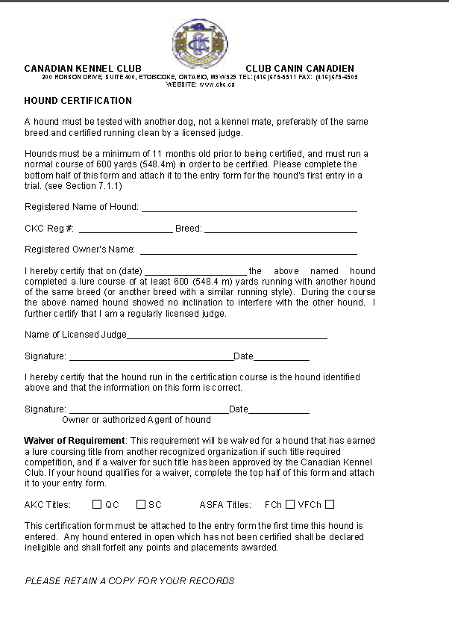

|  |  |  |  |  |  |  |  |  |  |
| --- | --- | --- | --- | --- | --- | --- | --- | --- | --- |
| OFFICE USE | ckclogo | | OFFICIAL CANADIAN KENNEL CLUB ENTRY FORM  **LURE FIELD TRIAL**  **September 24 & September 25, 2016**    **Whippet Club of BC** | | | | | | wcobc logo |
|  | | |  | | | | | |  |
| Make cheques payable to **WCOBC** and mail to: Marion Bomford, 504 – 1915 Pacific Court, Kelowna BC V1Y 8B3  ***This is a Computer ready form.***  ***Click and enter your information, print, and sign. Or Print and complete Clearly by hand*** | | | | | | | | | |
| **ENTER IN THE FOLLOWING CLASSES: *One entry form per hound*** | | | | | | |  | | |
| ☐ Open, ☐ Single  **LURE TRIAL SAT** ☐ **SUN** ☐  If this is the hound’s first trial in Canada a Hound Certification Form must be attached with dog info complete  Pre-entry - per dog per event/day all events. SAT $22.00 SUN $22.00 = $  2nd Hound Same Owner or WCOBC member pre entry (per dog per day) SAT $20.00 SUN $ 20.00 = $  Each Late/Day of Trial entry (without reservation- lure only) $30.00  Listing Fee for each entry without a CKC Number………….... = $ 9.32 **PER EVENT**  TOTAL ENCLOSED $ | | | | | | | | | |
| **BREED:** | | | | | **Call Name:** | | | ☐ **MALE**  ☐ **FEMALE** | |
| **Registered name of Hound:** | | | | | | | | | |
| **This hound is eligible for the following High Score recognition:**  ☐ FCh., ☐ FchX, ☐ Veteran.; ☐ FTE (First time entered) (attach completed Certification Form) | | | | | | | | | |
| Hound Registration: CKC REG. # | | | | **Check one and enter number**  Other registry # Type of # | | | | | |
| DATE OF BIRTH  **/ /**  Day Month Year | | **PLACE OF BIRTH**  Canada☐Elsewhere ☐ | | | | Please separate my hounds ☐ | | | |

REG’D OWNER(S):

OWNER’S ADDRESS:

E-MAIL ADDRESS:

PHONE #: Owner’s CKC membership #

BREEDER(S):

SIRE:

DAM:

NAME OF OWNER’S AGENT

AGENT’S ADDRESS:

email:

|  |
| --- |
| **Email confirmation TO: owner** ☐ **Agent** ☐ |
| I CERTIFY that I am the registered owner(s) of the dog or that I am the authorized agent of the owner(s) whose name(s) I have entered above and accept full responsibility for all statements made in this entry. In consideration of the acceptance of this entry, I (we) agree to be bound by the rules and regulations of the Canadian Kennel Club and by any additional rules and regulations appearing in the premium list. |
| **_____________________________________________________________________________________________________**  **SIGNATURE OF OWNER OR AGENT** |

***NOTE: Please include signed Waiver Form***

***WCOBC Waiver***

***Please include this signed document***

***with your entry form***

**WAIVER**

* I acknowledge that I, as exhibitor, handler and patron, know and abide by the “CKC Dog Show Rules”, and that I am familiar with their content.
* I agree that the Club holding this Show/Trial has the right to refuse this entry for cause, which the Club shall deem to be sufficient.
* In consideration of the acceptance of this entry and of the holding of the Trials and of the opportunity to have the dog judged and to win ribbons or trophies, I agree to hold the WHIPPET CLUB OF BC , their members, directors, governors, officers, agents, superintendents, show secretary and/or the owner or agent of the premises, and any employees of the aforementioned parties, harmless from any claim for loss or injury which may be alleged to have been caused directly or indirectly to any person or thing by the act of a dog while in or upon the show/trial premises or grounds or near any entrance thereto.
* I personally assume all responsibility and liability and I further agree to hold the aforementioned parties harmless from any claim for loss of a dog by disappearance, theft, death or otherwise, and from any claim for damage or injury to the dog, whether such loss, disappearance, theft damage or injury be caused or alleged to be caused by the negligence of the Club or any of the parties aforementioned, or by the negligence of any other person, or any other cause or causes.
* I hereby assume the sole responsibility for and agree to indemnify and save the aforementioned parties harmless from any and all loss and expense (including legal fees) by reason of the liability imposed by law upon any of the aforementioned parties because of bodily injuries including death at any time resulting there from, sustained by an person or persons, including myself, or on account of damage of property, arising out of or in consequence of my participation in this show, howsoever such injuries, death or damage to property may be caused and whether or not the same may have been caused and whether or not the same may have alleged to have been caused by negligence of the aforementioned parties or any of their employees or agents, or any other person.

Date____________________Signed____________________________________

Print name: __________________________________________________________